**Project Report Template**

**TITLE: RETAIL MANAGEMENT APLLICATION USING SALESFORCE**

**1. INTRODUCTION**

* 1. **.Overview**

Retail management refers to the process of helping customers find products in your store. It includes everything from increasing your customer pool to how products are presented, and how you fulfill a customer's needs. A good store manager helps customers leave the store with a smile.

Retail management refers to the process of helping customers find products in your store. It includes everything from increasing your customer pool to how products are presented, and how you fulfill a customer's needs.

A good store manager helps customers leave the store with a smile. They also are responsible for:

* Motivating Employees
* Developing startegics to increase the customer pool
* Growing store traffic
* Meeting sales goals
* Ensuring customer satisfaction
* Improving profitability
* Preventing shoplifting

**1.2.Purpose:**

Retail management optimizes internal processes such as inventory management, offline and online storefronts, warehouse operations, payment and accounting, and human resources.

Retail management improves overall company cohesion. Retail store management improves customer experience and boosts customer satisfaction.

**2.Problem Definition & Design Thinking**

**2.1 Empathy Map**

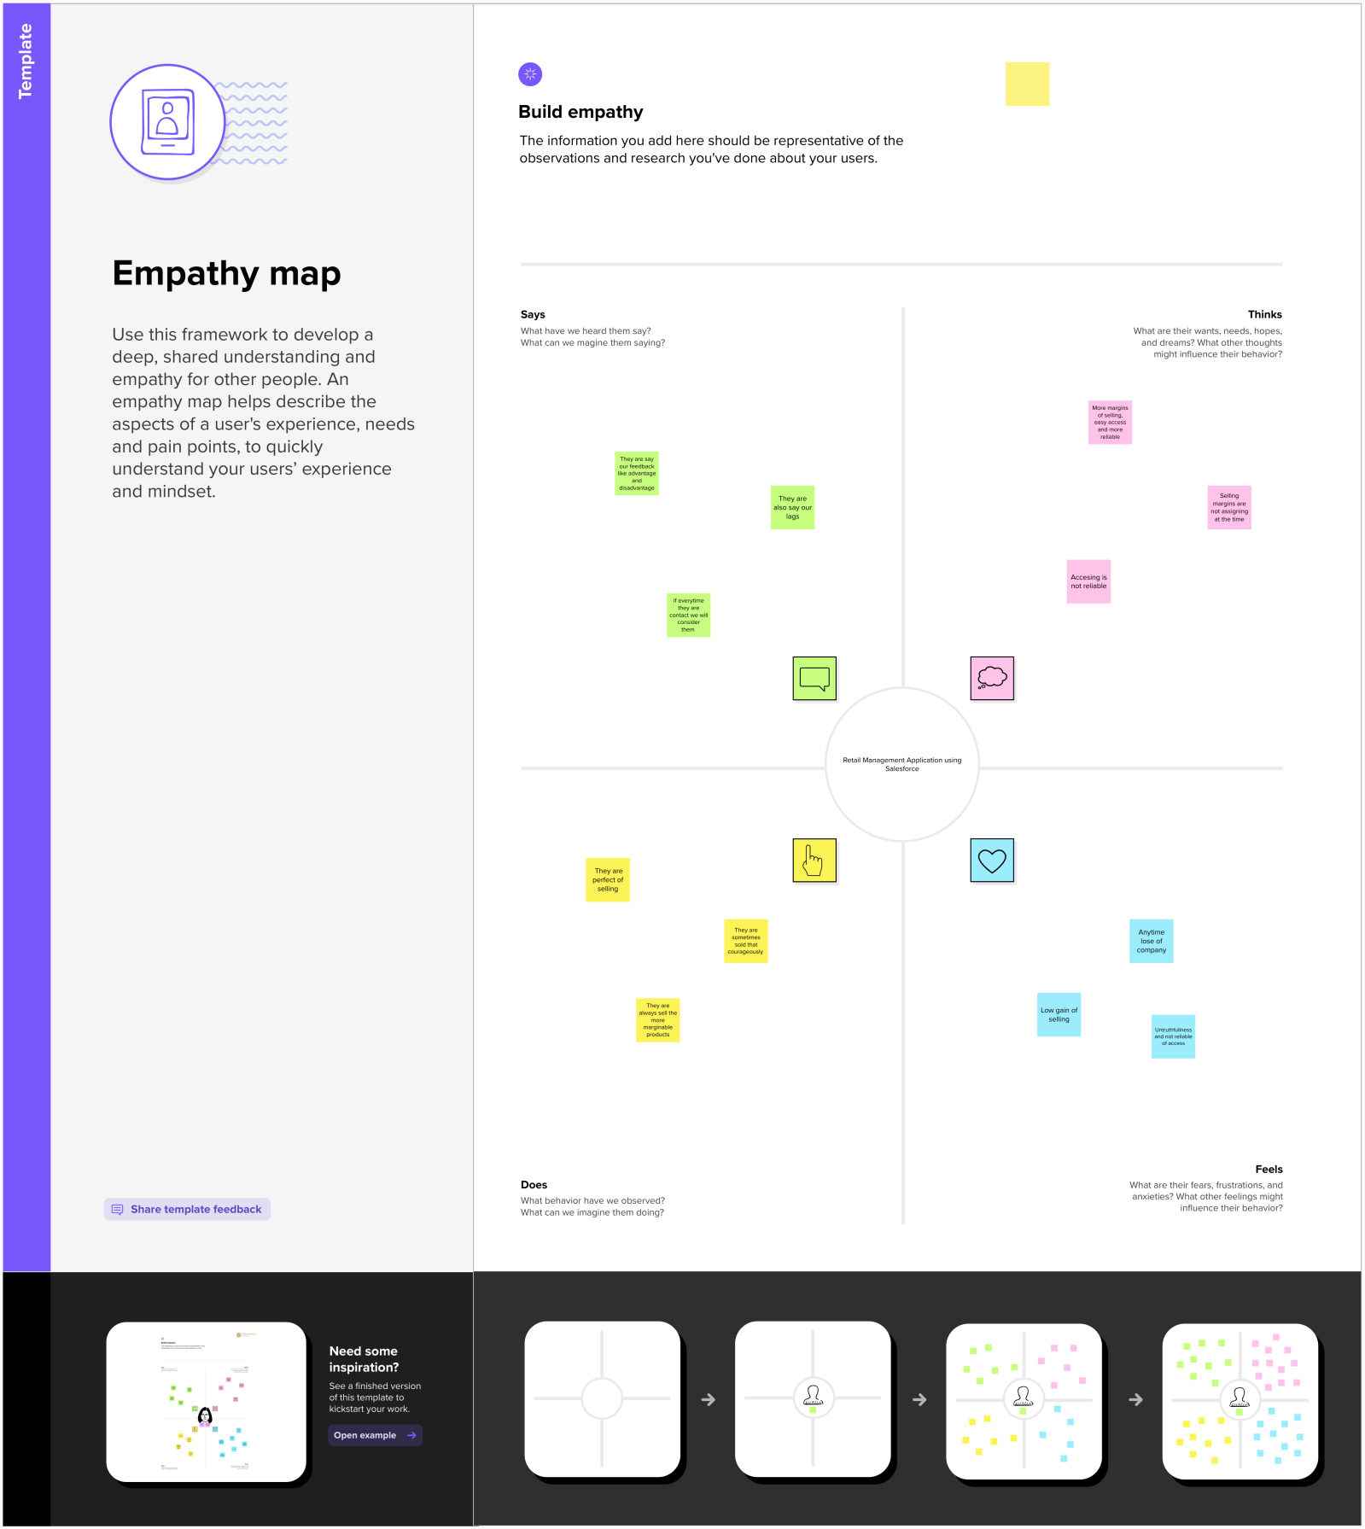

**2.2 Ideation & Brainstorming Map**

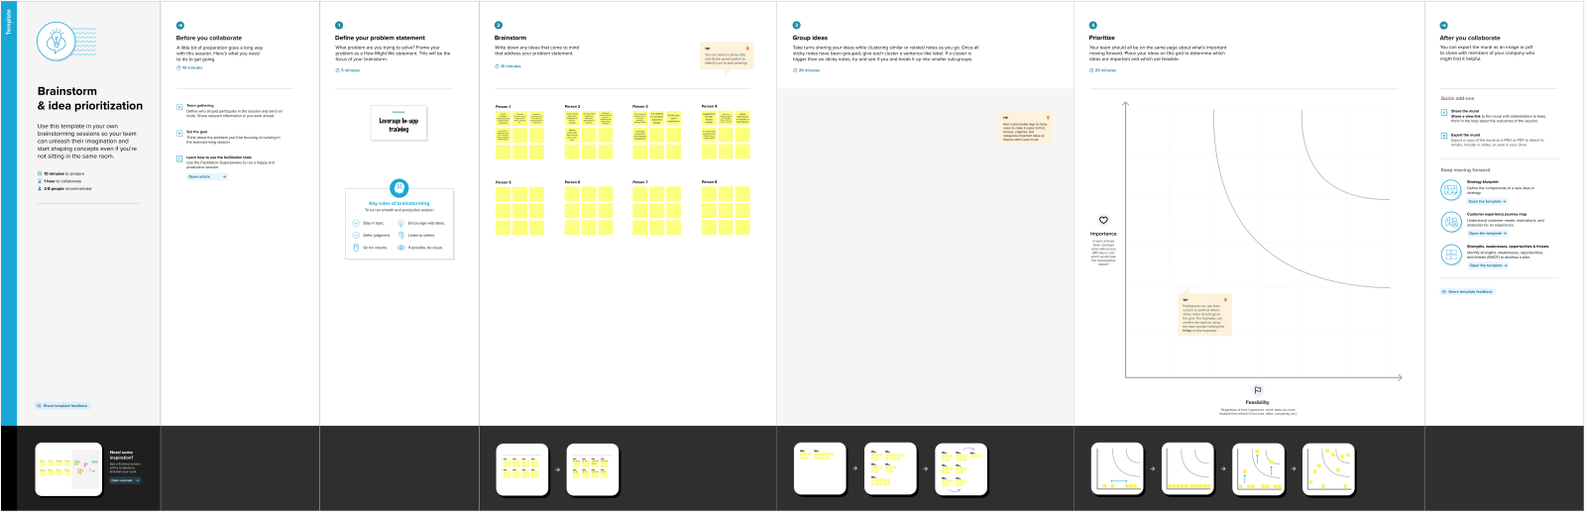

**3. RESULT**

**3.1 Data Model:**

|  |  |
| --- | --- |
| **Object Name** | **Field in the Object** |
| * + **Warehouset** | |  |  | | --- | --- | | **Field Label** | **Data Type** | | Warehouset Name | Text(80) | |
| **Contact** | |  |  | | --- | --- | | **Field Label** | **Data Type** | | Contact Name | Text(80) | |
| **Lead** | |  |  | | --- | --- | | **Field Label** | **Data Type** | | Lead Name | Text(80) | |
| **Display/Tracking** | |  |  | | --- | --- | | **Field Label** | **Data Type** | | Disapatched | Checkbox | | Expexted date of delivery | Date | | Retail | Master detail | | Tracking ID | Text(80) | |
| **Retail** | |  |  | | --- | --- | | **Field Label** | **Data Type** | | Retail Name | Text(80) | |

**3.2 Activity & Screenshot :**

**Object Creation :**

**1.Warehouset**

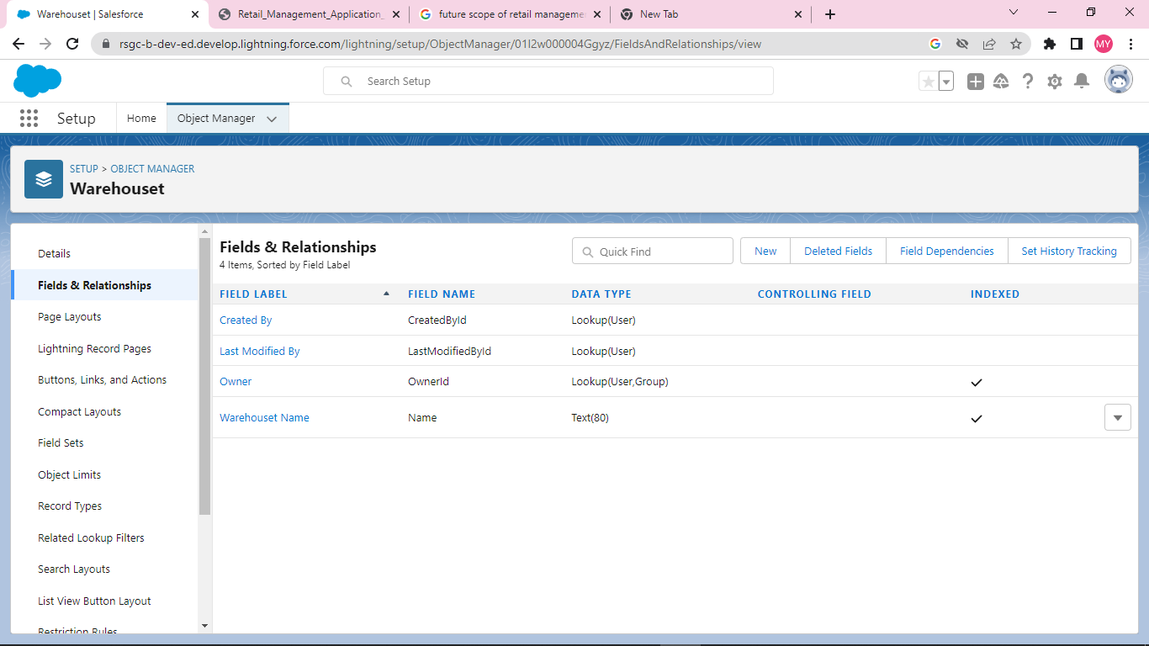

**2.Contact**

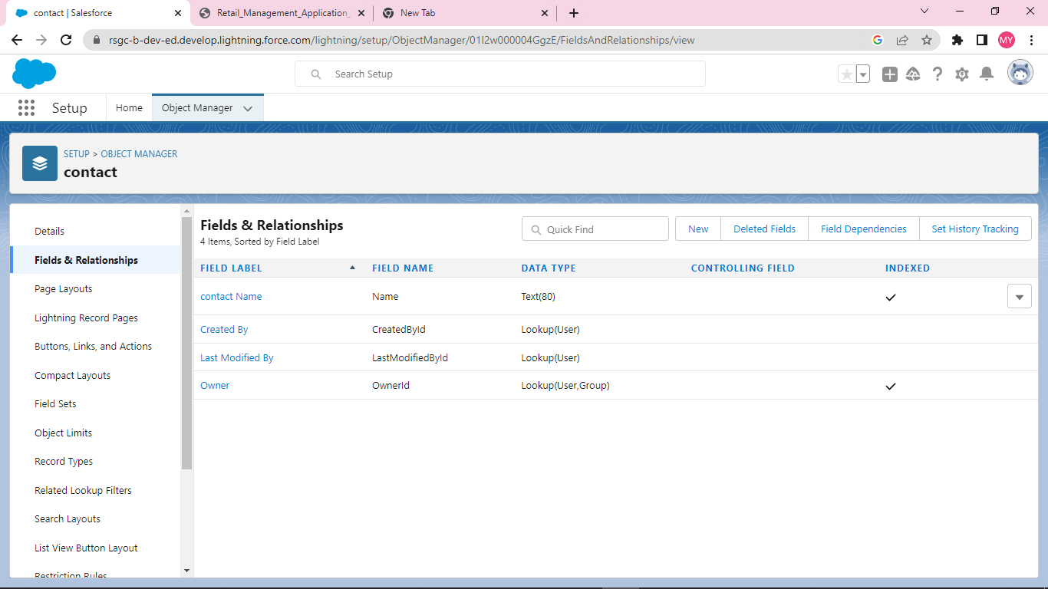

**3.Display/tracking**

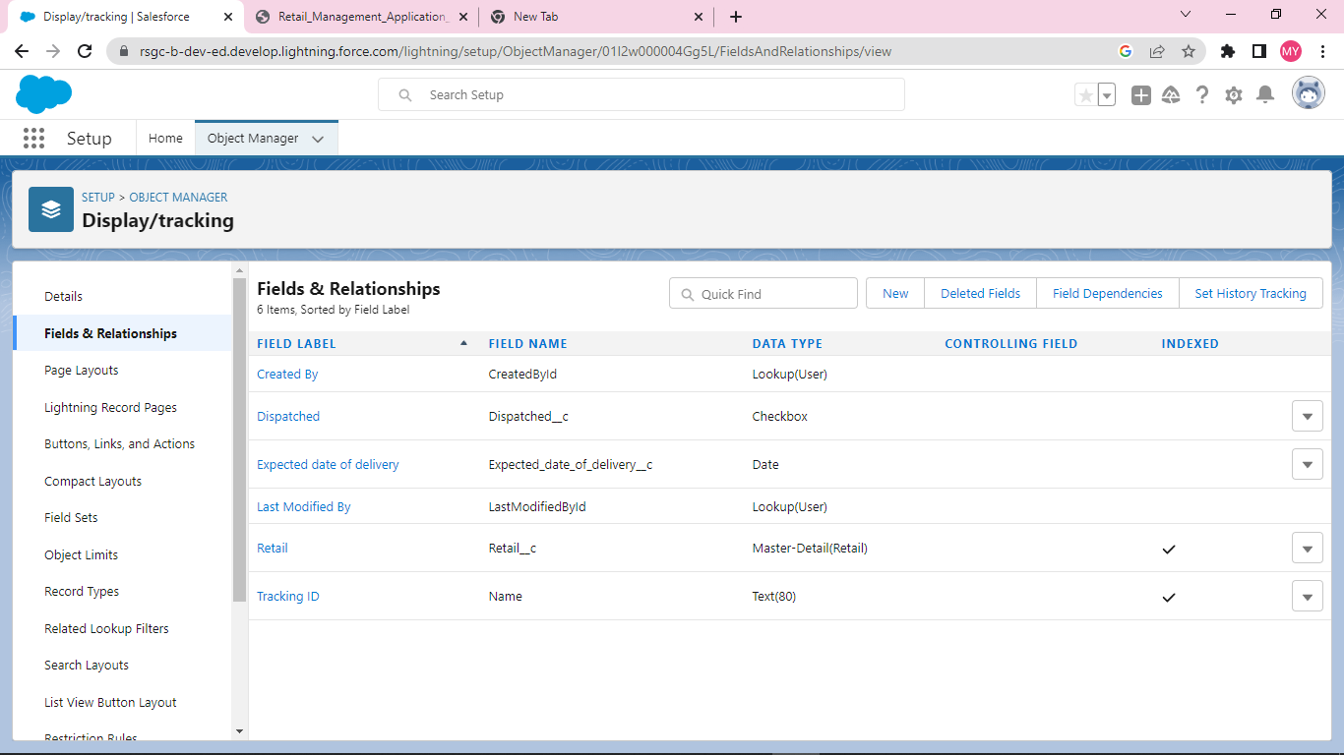

**4.Lead**

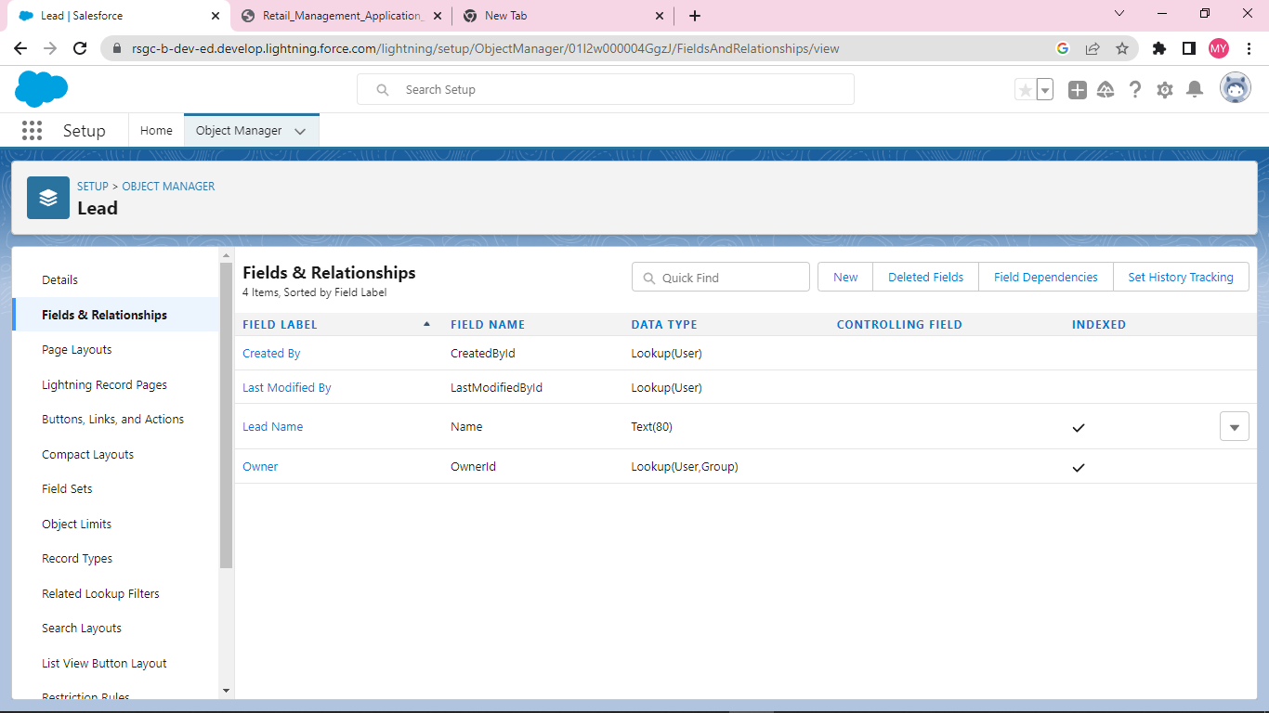

**5.RETAIL**

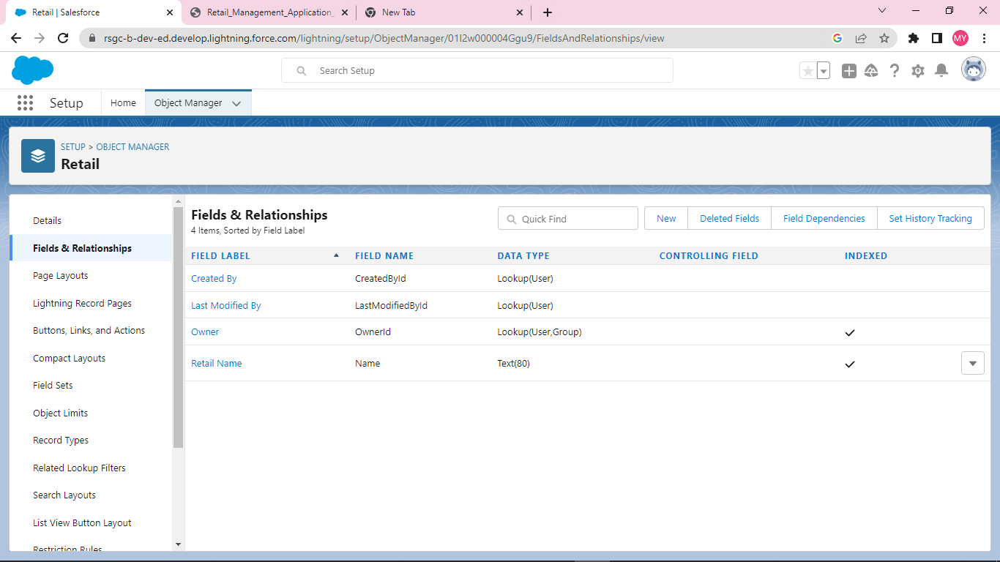

**TABS :**

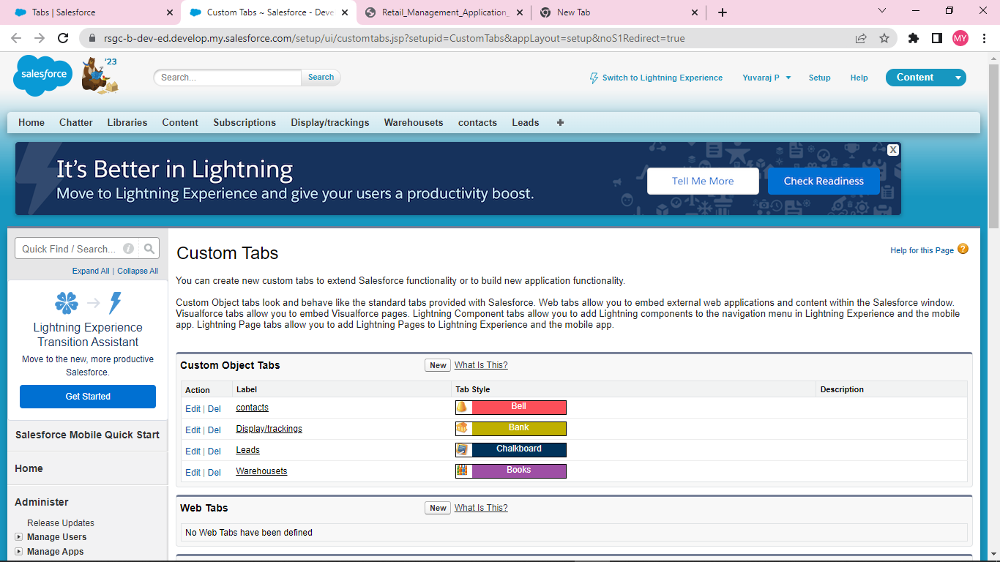

**USERS :**

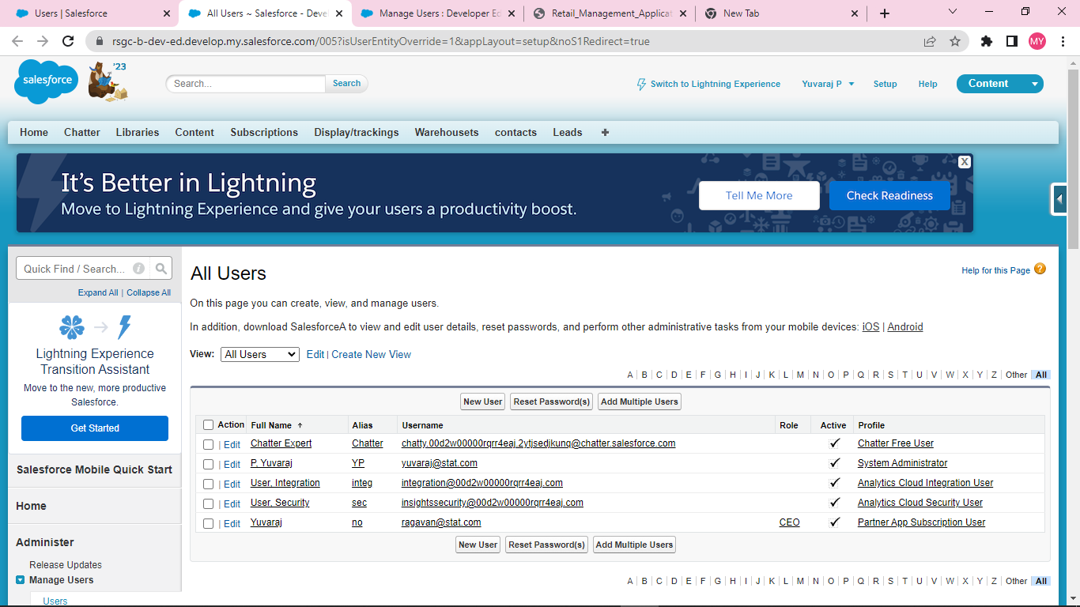

**Application :**

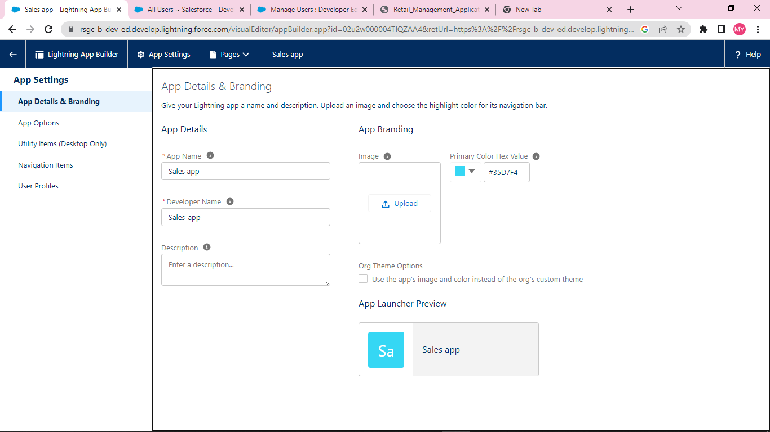

**Validation Rule :**

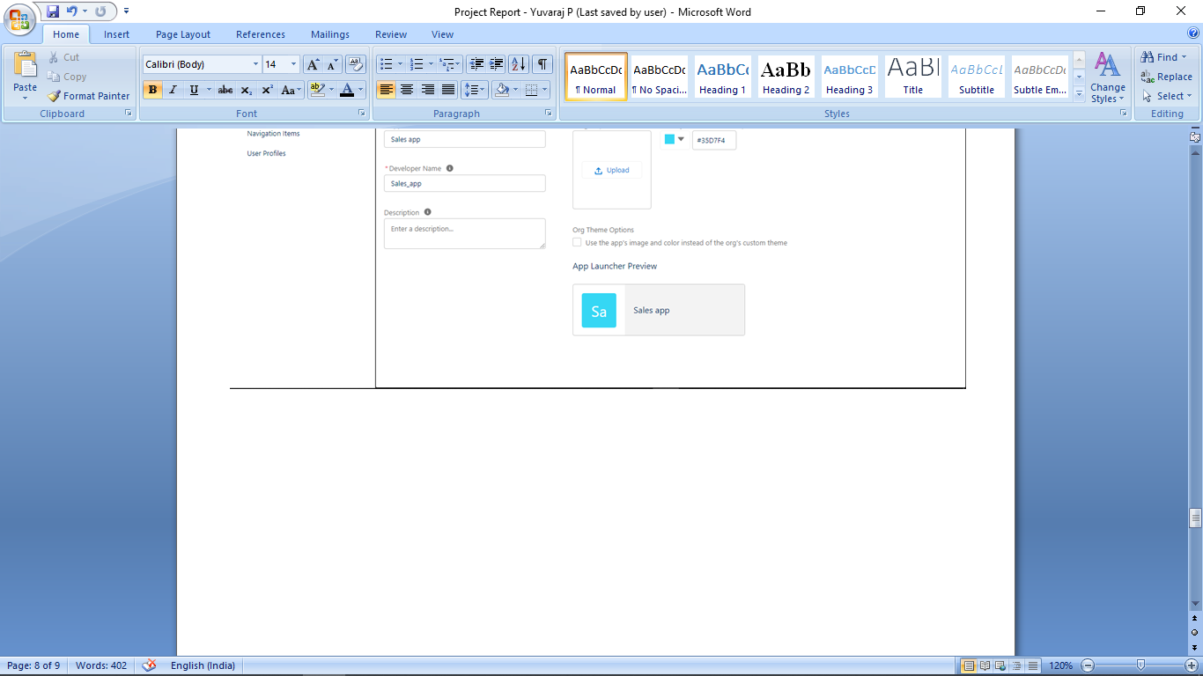

**Reports :**

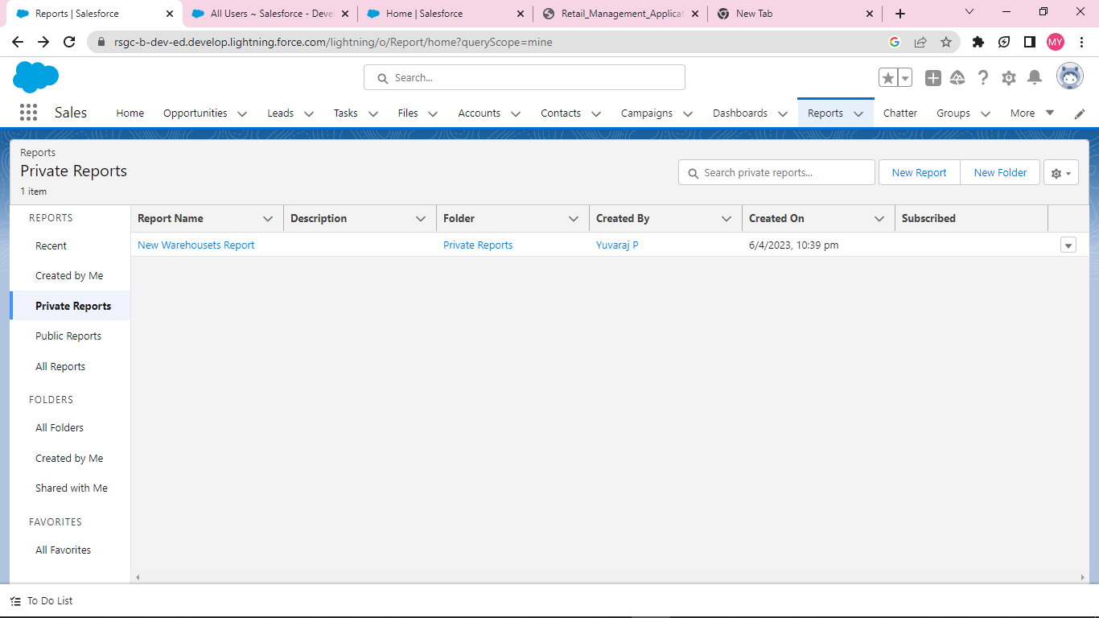

**Dashboards :**

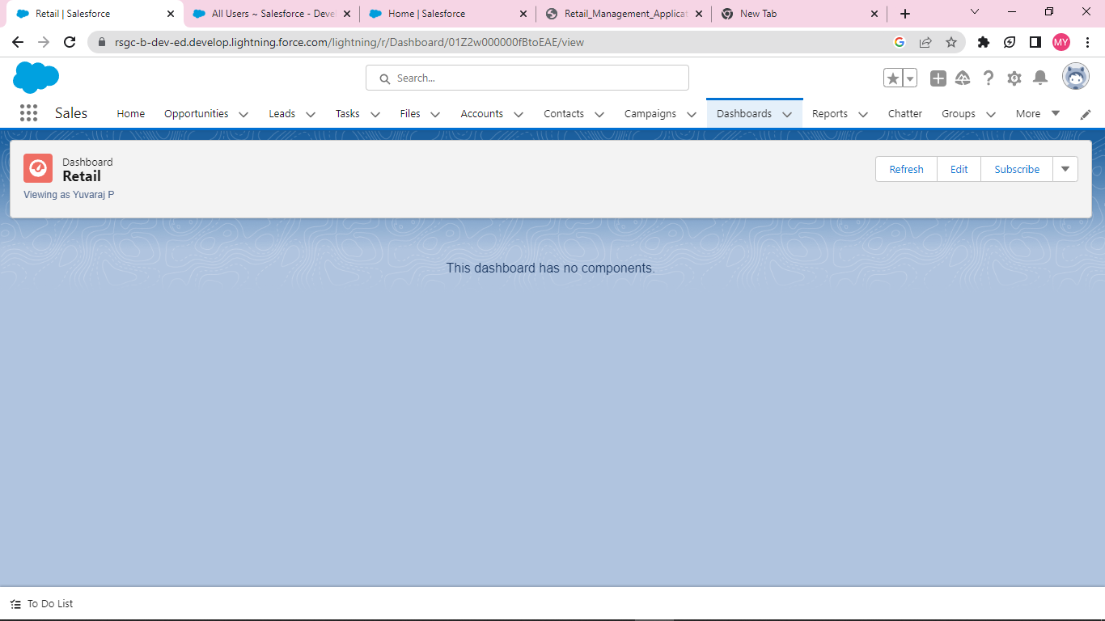

**4. Trailhead Profile Public URL :**

Team Lead – YUVARAJ P - <https://trailblazer.me/id/pyuvaraj113>

Team Member 1 – RAGAVAN S- https://trailblazer.me/id/ralex122

Team Member 2 – BHARATHI P- https://trailblazer.me/id/hgahlot3

Team Member3 – ABINESH M - https://trailblazer.me/id/mabinesh123

**5. ADVANTAGES & DISADVANTAGE :**

**Advantages:**  
 **Optimises all store processes**:

A company can increase the efficiency of each process and better ensure a high-quality standard for employees.

As a result, executives may accomplish their goals at faster rates.

**Disadvantages:**

## Difficult to Sell To

## Lower Profit Margin

## Impersonal

## Competition

**6. APPLICATIONS:**

IT helps to store customer data, which the retailer can then use to reach out to customers.

**7. CONCLUSION:**

we have explored the meaning of the terms retailing, marketing and marketing communications.

**8. FUTURE SCOPES:**

The future of retail will feature **a high level of online penetration.**